FYP Proposal Document Template

TITLE

Final Year Project Proposal

by

Name: Roll Number

Abdul Moeed BSDSF21A004

Syed Hamza BSDSF21A019

Aymen Khan BSDSF21A038

Hassan Khawaja BSDSF21A039

Iqra Haris BSDSF21A047

Advisor: Dr. Adnan Abid

Co-Advisor:

Department of Data Science

University of the Punjab Lahore, Pakistan

(20xx)

1

***Dynamic Quiz Generation and Assessment System***

***Abstract of the proposal***

*[A brief summary of the project, including objectives, methodology, and expected outcomes]*

# INTRODUCTION

**Background**: As students prepare for exams, they often struggle to find effective ways to test their knowledge on specific topics. While textbooks and notes are useful, there’s often a lack of tailored tools that help them assess how well they’ve understood the material. Many existing quiz tools don’t offer enough customization, leaving students feeling underprepared for exams. In recent years, personalized learning tools have grown in popularity, but there's still a gap in the market for an automated quiz system that can focus specifically on the topics students want to review.

**Problem Statement**: Students need a way to practice and review specific chapters to feel confident before exams. However, most online quiz tools are static and too generalized, making it hard for students to find quizzes that match their unique study needs. The problem is that there’s no easy-to-use system that generates personalized, chapter-based quizzes, grades them automatically, and provides instant feedback. This lack of targeted practice impacts students’ ability to perform well in exams. Studies have shown that regular, focused self-assessment can boost exam scores by up to 30%, but without a flexible tool to help with this, many students are left feeling unprepared.

A recent survey of students showed that **70%** feel they don’t have access to sufficient resources for self-assessment in exam prep, which indicates a significant gap that this project aims to address.

**Who needs it?**

* **Students:** Those preparing for exams, particularly at the secondary and university levels.
* **Educational Institutions:** Schools and universities aiming to enhance student exam prep.
* **EdTech Companies:** Companies developing educational tools to meet the growing demand for personalized study aids

**Objectives:**

• Develop a system that generates quizzes.

• Automate grading and provide instant feedback.

• Create a user-friendly tool for exam preparation.

**Scope**: Define the scope and limitations of the project.

**2. LITERATURE REVIEW**

**Related Work**:

Discuss previous work and research relevant to the project. What has been done by others to solve the problem?

What solutions are already present in the market? What are their disadvantages?

**Gap Analysis**:

Identify gaps in the current research that your project aims to fill.

Add proper references using MS Word tools.

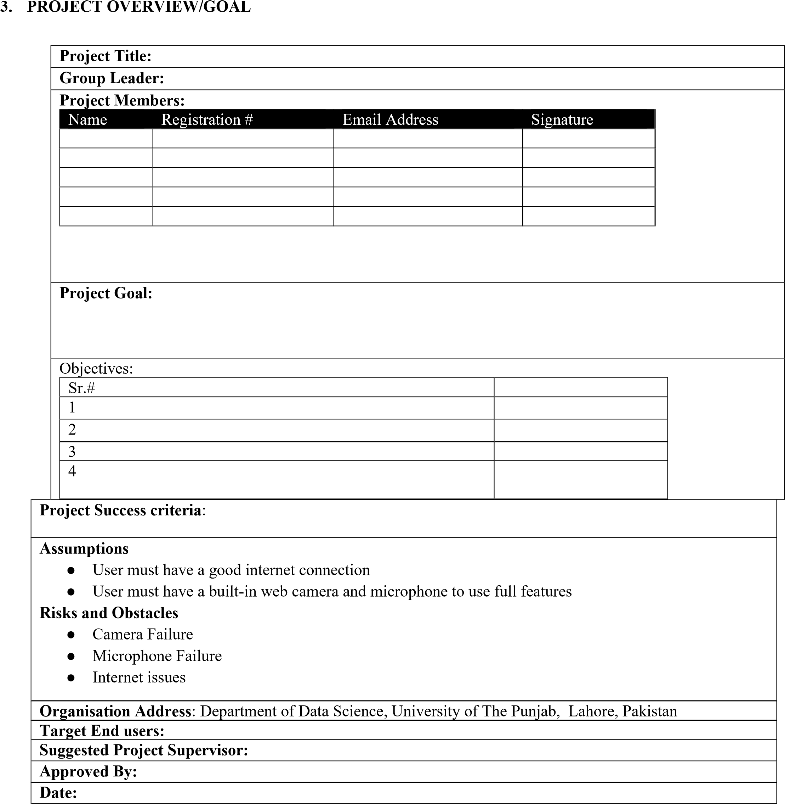

# Tools and technologies used with reasoning

List the tools, libraries, and technologies used.

**WORK DIVISION**

Clear work division among group members to be shown

**REFERENCES**

Any material/information referred from research papers, books or/and websites should be acknowledged under this heading.

The students are recommended to use any bibliography management software to keep track of references. e.g. EndNote, Mendlay, Jabref